
Procedure 2025

ArcelorMittal Construction France Procedure 1.1.1.10

Modification of deadlines

Context
We sometimes must intervene to change due dates for the following reasons:

  - Conditions were not changed before the order was released

  - Computer bug (regularly occurs for 45-day month-end conditions with invoices dated 16th of the month. For example, if an invoice is dated 16/10, it will be due on 31/11, but this is not correct, it should be due on 31/12).
  - The invoice is dated 29/30/31 of the month, but the customer received the goods on 01 or 02 of the following month. The invoice date is then considered to correspond to the delivery date. The due date is recalculated accordingly. The delivery note must be provided as proof.

Validation stage

Issuer: Poland?

Branch manager: Stéphane H.

Integration: Poland?

Control: Stéphane H.

If the form contains errors or is no longer relevant because the customer has paid in the meantime, you will need to reject the form ("Reject" button on the left) so that it can be returned to the issuer, who can either make the necessary changes or cancel it.

QN due date modification form

è Go to Qual'Net and select the "Customer due date modification" module.

“Click on ‘New form’ at the top right in orange, and follow the procedure.”
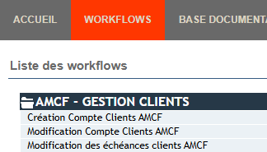

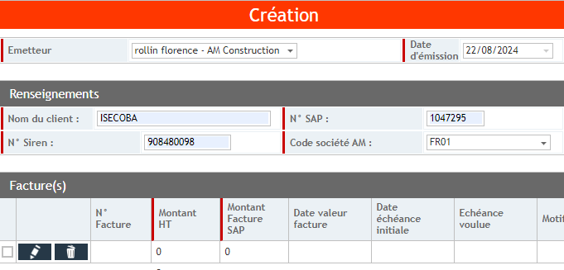

Click to fill in the information :
- Invoice no
- SAP invoice amount (incl. VAT)
- Invoice value date
- Initial due date
- Desired due date
- Reason
Activate the HERNANDEZ Stéphane pilot, then VALIDATE THE FORM

If you have an e-mail requesting a change of due date from the customer or sales representative, you should attach it to the form:
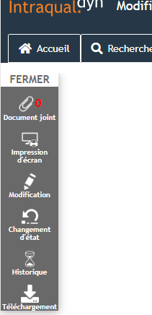
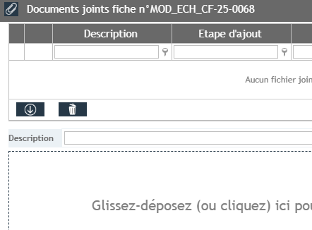

- Batch QN (procedure 1.1.1.0)

Complete the QN batch file (K/Customer credit/QN batch) on the "MODIF ECH 2025" page.
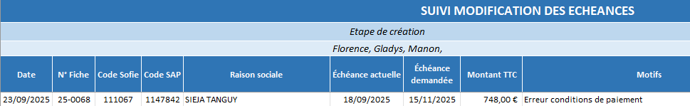

This file is used to keep track of requests made, their status and to check the changes made:
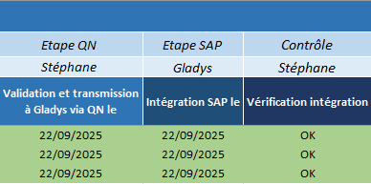

On: 03/11/2025
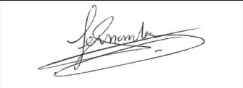
Procedure validated by : S.HERNANDEZ

